COS20015 – Fundamentals of Data Management

Distinction Report

DARREN FREDERICK CHAN CHYUN YAW (100085926)

# Introduction

Car manufacturing is a complex process which involves aspects of management, machinery, staff, delivery and endpoint-sales. To handle these processes, a database is created to organize these the data of these entities to be easily referenced such that the process of manufacturing a car is smooth.

# Overview of the System and its Business rules.

## Overview of the System

The database organizes data about the manufacturing process of a vehicle from which factory it is produced from, what production line it was produced from, what model and category it was, who manned the production line, what batch it came from, who inspected the batch, where it was loaded for shipping at which shipping port from which port lane, and which salespoint it is shipped to.

## Business Rules

A staff member has a first name, last name, gender, age, role, hire date, phone number. They can have many roles and work in many factories. Each staff is given a unique identifier called a staffID.

A model has the year it started production, unit price and a category. A model can have many categories such as hatchback, sedan, SUV, MPV etc. Each model is given a unique model number called modelID.

A factory has factory address, fax number and a phone number. A factory is managed by a manager from staff. Each factory is given a unique identifier called factoryID.

A production line is identified using a productionlineID. Many factories can have many production lines.

Many factories can have many production lines which can produce many models and they have an daily output, date of last maintenance, date of next maintenance and the uptime or operational time, how long the production line has been online.

Many factories have many production lines which are worked by many line workers. These line workers keep the production line in the factories running 24/7. The line workers need to log the beginning of their shifts, the end of their shifts and the date of that shift.

A batch has a batch size and batch date. A batch can receive many models from many production lines from many factories. Each batch is uniquely identified by a batchNo.

After a batch is produced, it will undergo inspection from a staff whose role is inspector. An inspector will inspect a batch. They will log the inspection date and inspection status after inspecting a batch and may give comments regarding the batch. Many batches can undergo inspection by many inspectors.

A factory will have one shipping port with many port lanes, each port lane has a port lane status. Each factory shipping port is managed by one port manager. The shipping port is uniquely identified by a shippingportID and the port lane is uniquely identified by a portlaneID.

A shipment has a shipping dock which is part of a factory’s shipping port, the batch is it carrying, the salespoint it is to be shipped to, and the date it is shipped. Many batches produced from many production lines and are loaded into shipping docks that are part of shipping ports of many factories. A shipment is uniquely identified by a shipmentID.

A salespoint has an address, a phone number and a fax number. Each salespoint is uniquely identified by a salespointID.

# Entity Relationship diagram

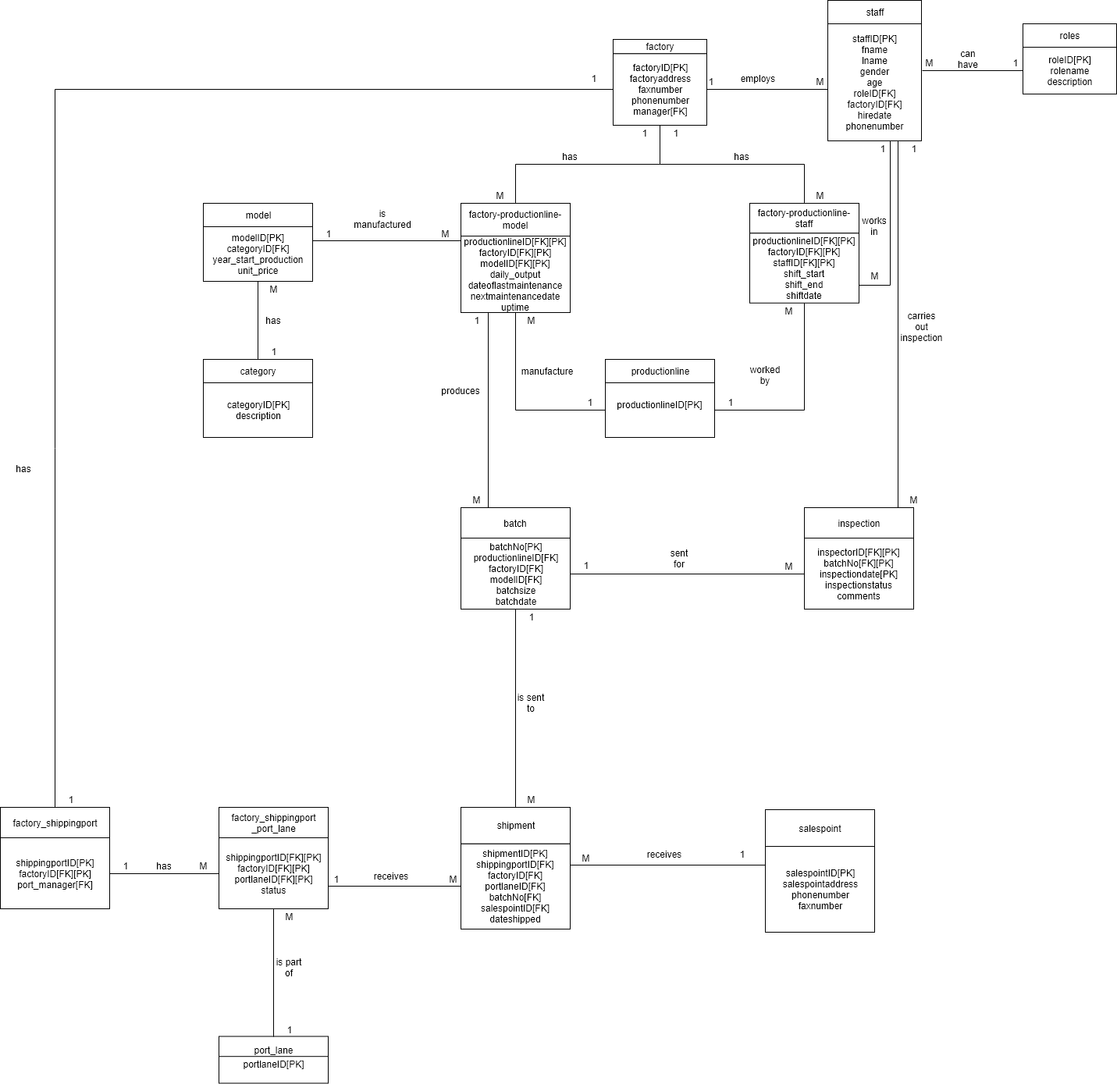

# Use Cases

The database offers many benefits for managers to lookup data regarding many aspects of the process of a manufactured vehicle.

Managers can contact other factory managers by retrieving either the phone number, factory address, or the fax number of the other factory for communication. They can quickly look up who manages the other factory by retrieving that data from the factory database.

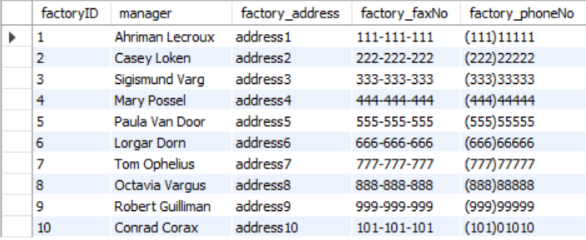

Managers can also retrieve data regarding employees from the staff database. Staff reports generally contain the staff name, staff role, which factory they work in, their phone number, and the staff hire date.



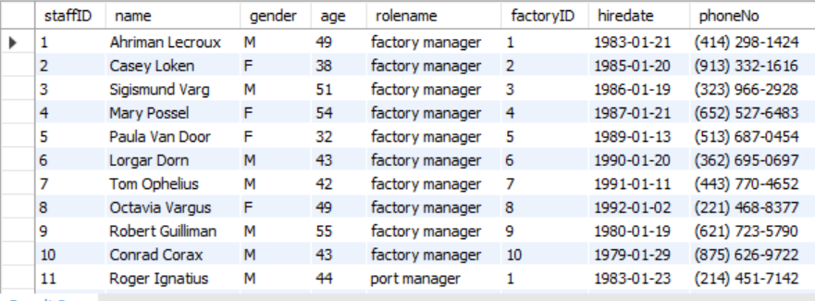

The database can retrieve information of the models being manufactured in any factory.

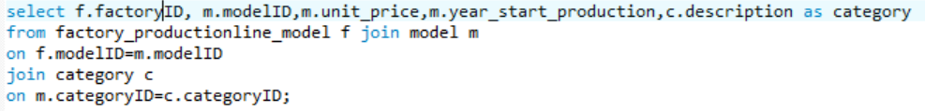

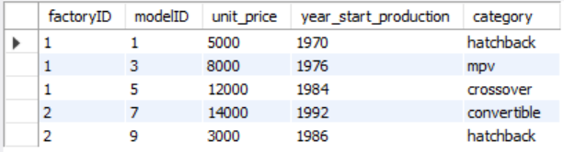

It can also retrieve which specific production line it was produced in, also, it is able to retrieve the daily output of any model from any production line from any factory. The database is also able to retrieve data about the last maintenance date of the production line and the uptime or how long the production line has been in non-stop service in days, the date of the next maintenance varies among the individual production lines.



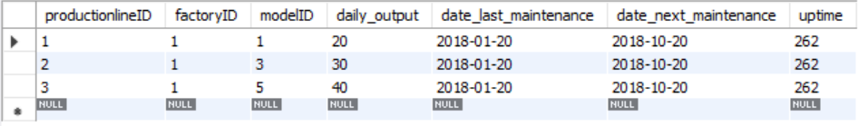

The database can also retrieve who worked which specific production line, it can retrieve their data about when they started their shifts, ended their shifts, the date of the shift and the duration of the shift.

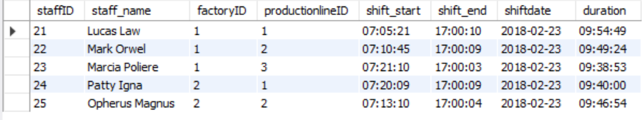

Managers can retrieve batch information, especially regarding the batch size and the date the batch is produced. More importantly, managers can track which factory and production line that the batch is produced from.



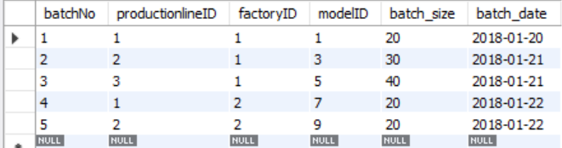

Data can be retrieved from the inspection database to see logs of past inspections of different batches, their inspection date, who inspected the batch, and their inspection outcome or inspection status and comments regarding the batch.



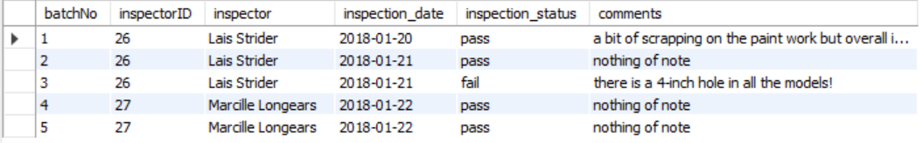

Furthermore, the database can produce reports regarding shipping of the batches. The database can organize and retrieve data of any batch that is sent to any port lane at any shipping port of any factory, which salespoint that batch is to be shipped to, and the date the batch was shipped.



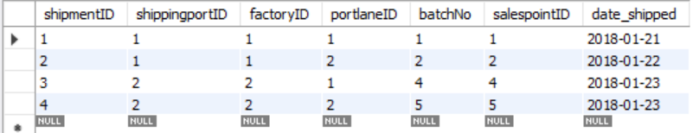

In factory_shippingport database, managers can find out who runs the shipping port of any factories and their phoneNo.

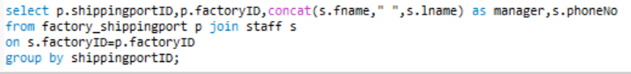

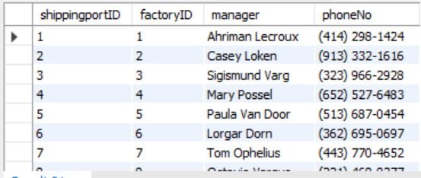

In the factory-shippingport-portlane database, managers can check the status of the port lane of from any shipping port from any factory, whether it is available or occupied.



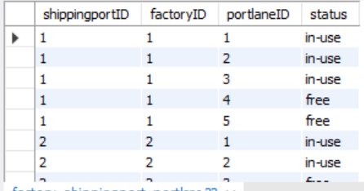

Moreover, managers can retrieve data about of salespoints, mainly the address of the salespoint, the salespoint phone number of the salespoint and the fax number of the salespoint. This is to allow factory managers to conduct business discussions quickly over communication media using the data retrieved from the salespoint database.



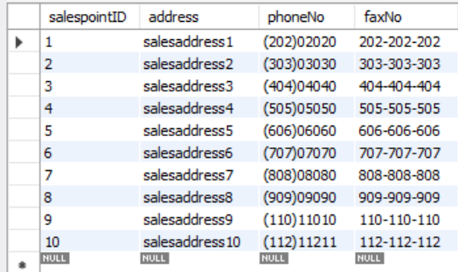

The database organizes and retrieve data of the potential profit of each factory in a year.



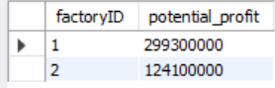

# Conclusion

The database is able to fulfil the needs of a factory manager in the management of their factory in day to day basis, retrieving mission critical information to keep the production of cars running, and communicate effectively with factory staff and salespoint that sales the models their factories produce.